Record Note
2nd-Biannual Regional Focus Group Meeting on SME Finance
Name of BSC Office: | SBP BSC FAISALABAD
Event Category: | Focus Group Meeting (Online via Zoom)
Program Title: | Online 2nd Biannual Meeting of Regional Focus Group  On SME Finance
Main Responsibility & Cluster (Name of Organizing Association) | SBP BSC Faisalabad
Event Date: | April 07, 2022
Event Time: | 10:30 AM – 12:30 PM
Event Location (Venue & City): | Via Zoom Application, SBPBSC Bank Faisalabad
Presentations made By: | - AFU Officials, SBP BSC Faisalabad  - DFSD Officials, SBP BSC Head Office, Karachi  - Regional Heads of Banks
Total no. of participants: | 30
Summary of Discussion:
Proceedings of the session commenced with Tilawat e Quran e Pak.

Mr. Sarfraz Ahmed Nadeem, Chief Manager-SBP BSC Faisalabad welcomed the participants. While opening the session, he highlighted the importance and key role of Small & Medium Enterprises, SME Finance and banks having portfolio in our economy. In his discussion, he apprised that SME is the most important sector of the economy as 90% of business enterprises are SMEs in the country; their contribution is 40% in national GDP and 25% in export earnings. Further, he highlighted that SAAF scheme is first initiative of its kind by SBP to promote SME financing in the country. Under this, Refinance and credit guarantee scheme, selected 08 banks will get Refinance from SBP at 1% p.a. and extend financing to SMEs at a rate of up to 9% and up to Rs.10 million amount may be availed by new SME borrowers.

Thereafter, he asked AFU team Faisalabad to carry on the proceedings of the meeting by discussing performances of different banks operating in Faisalabad Region.

Mr. Tahir Abbas, ACM SBP BSC Faisalabad proceeded ahead for discussion on data/Information received from different banks of Faisalabad region and asked following banks one by one to present their portfolio:

- The Bank of Punjab.
- MCB Islamic Bank Limited.
- The Bank of Khyber.

Some highlights from the presentation of banks:

- The Bank of Punjab official apprised that they are increasing HR strength dealing in SME financing which is currently 20 officials.
- ACM AFU advised BOP official to expedite the processing of women borrower cases.
- BOP Official informed that they have conducted awareness sessions on PMKJ and SAAF schemes, which helped them to mobilize potential borrowers of the region and achieve assigned targets.
- MCB Islamic Bank Official informed that some important decisions for promotion of SME financing have been made in recent board meeting. Resultantly additional equity will be injected by the bank and HR strength will be improved.
- Further, MCB Islamic bank official apprised that they financed 19.5 Million under renewable energy scheme.
- The bank of Khyber official informed that they have their major portion of SME financing in Sargodha region.
- ACM AFU advised the BOK official to improve their non-financial advisory services.

Some highlights from the presentation of AFU:

Mr. Tahir Abbas ACM AFU discussed the performances of different banks operating in Faisalabad region and highlighted their progress from presentation prepared by AFU. He emphasized banks to enhance financing in SBP Schemes with special focus to enhance financing to women borrowers.

Later, Mr. Tahir Abbas- Asst. Chief Manager – AFU welcomed comments and suggestions from the participants of meeting. He expressed his hope that banks operating in the region would be actively participating in future meetings as well, and contribute towards smooth functioning of SME sector, keeping in view its overall significance in economy.

Concluding the meeting, Mr. Tahir Abbas thanked participating banks and they ensured their cooperation in future.

There being no other point, the meeting ended with a vote of thanks to the chair.

Action Plans/Agreement Points: [What, Why, Impacts, Task, Assigned to, Timeline]
N/A

Suggestions/ Queries/Issues or any other discussion points other than the agenda of program:
- Mr. Imran Area Manager Khushahli bank suggested including segment wise and industry wise financing details in AFU presentation.
- Ehtasham ul Haq Regional Head Askari Bank suggested that PR’s of SME Financing should be revised and linked with rate of dollar for improvement of financing to SME sector.
Deferred Items [Describe any items that may have been deferred for a later discussion]
[Nil]

Annexure A
List of Attendees
Sr# | Name | Designation | Bank/Institute
1 | Sarfraz Ahmed Nadeem | Chief Manager | SBP-BSC Faisalabad
2 | Asif Jabbar | Deputy Chief Manager | SBP-BSC Faisalabad
3 | Tahir Abbas | Asst. Chief Manager | SBP-BSC Faisalabad
4 | Zareen Baloch | Asst. Director | DFSD, SBP BSC HO, Karachi
5 | Abid Masood | Officer – AFU | SBP-BSC Faisalabad
6 | Laiba Asif | Officer – AFU | SBP-BSC Faisalabad
7 | Naghma Altaf | Branch Manager | First Women Bank Ltd.
8 | Waqas Ahmed | SME Focal Person | Meezan Bank Ltd.
9 | Faisal Kamal | Regional Head | Allied Bank Ltd.
10 | Muhammad Imran Zafar | SME Focal Person | Mabib Metropolitan Bank Ltd.
11 | Syed Fazal Abbas Zaidi | Regional Head | Bank Alhabib
12 | Ehtesham Ul Haq | Regional Head SME | Askari Bank Ltd.
13 | Ahmad Zia | SME Focal Person | The Bank of Khyber
14 | Hammad Rasool | SME Focal Person | National Bank of Pakistan
15 | M Ali Chauhan | Regional Head | Dubai Islamic Bank
16 | Abid Ali | Regional head | HBL
17 | Muhammad Kashif | Area Manager | Khushhali Microfinance Bank Ltd.
18 | Zulfiqar Bhatti | Area Manager | MCB Bank Limited.
19 | Sohaib Siddiqi | SME Focal Person | MCB Islamic Bank Ltd.
20 | Shahid Amin | Regional Head | Al Baraka Bank Ltd.
21 | Muhammad Yasin | SME Focal Person | JS Bank Ltd.
22 | Zishan Yousaf | Regional Head | The Bank of Punjab
23 | Muhammad Atif | Regional Manager (Op) | Silk Bank Ltd.
24 | M Irfan Butt | Regional Head | Soneri Bank
25 | Abrar Saleem | SME Focal Person | Allied Bank Ltd.
26 | M Usman | SME Focal Person | Soneri Bank
27 | Rukhsana Bokhari | Regional Head | First Women Bank Ltd.
28 | Sajjad Chaudhary | SME Focal Person | Askari Bank
29 | Tariq Sajjad | SME Focal Person | United Bank Limited
30 | Haroon Rashid | SME Focal Person | -

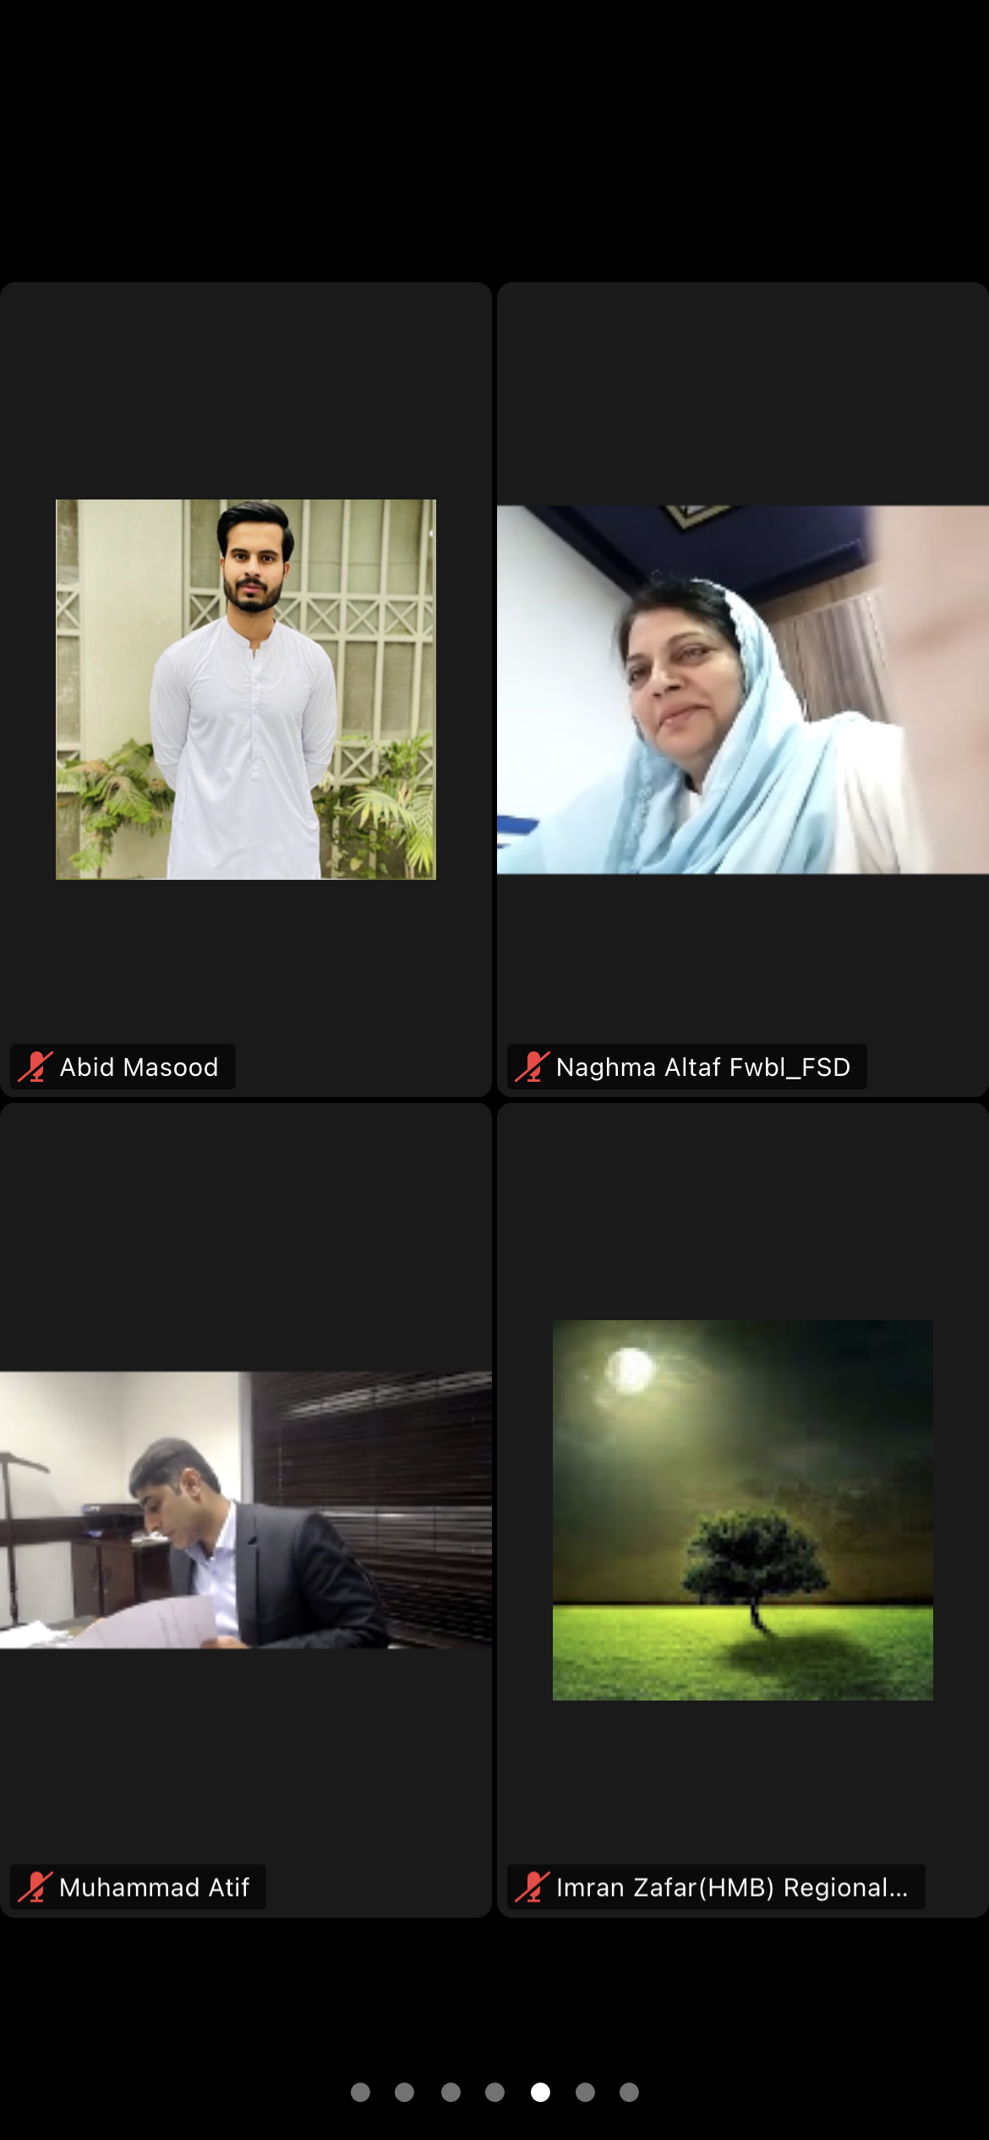
Screenshots of Meeting

